Socio-Economic Indicators and Crime: A Regression Analysis of DV and Violent Crime (Queensland)

**Author:** Davi Santos Meloni **Date:** April 2025

**Note**: This analysis was conducted as part of a self-guided learning project. While the methods and interpretations are grounded in established statistical practices, this is the author's first attempt at modeling real-world datasets. As such, results should be viewed as exploratory and subject to the typical limitations of an individual learning exercise.

Executive Summary

*This report investigates the relationship between socio-economic conditions and crime rates, with a focused lens on domestic violence (DV) and violent crimes. By using multiple linear regression models, we examined how three SEIFA indexes—IRSD (disadvantage), IER (education and employment), and IEO (economic opportunity)—predict log-transformed crime rates across local government areas in Queensland. The findings offer evidence that these socio-economic indicators are statistically significant predictors of both DV and violent crime patterns.*

## 1. Introduction

*The purpose of this analysis is to better understand how socio-economic factors relate to violent and interpersonal forms of crime. Domestic violence-related and violent offences were chosen due to their severe impact and strong ties to social and community dynamics. In contrast, property and drug-related crimes were intentionally excluded to provide a clearer focus on the role of community-level disadvantage without potential noise from crimes more related to economic gain or substance use.*

## 2. Data Sources and Preparation

* ***Crime Data****: Crime data was collected from 2018 through to the most recent available reporting period. Raw offence types were grouped into broader categories, with this analysis focusing specifically on:*
  + ***Violent Crime***
  + ***DV-Related Crime (Breach Domestic Violence Protection Order)***
* ***Socio-Economic Data****: SEIFA indexes (2021) were obtained from the Australian Bureau of Statistics. The following indexes were included:*
  + ***IRSD****: Index of Relative Socio-Economic Disadvantage*
  + ***IER****: Index of Education and Employment*
  + ***IEO****: Index of Economic Opportunity*

*These data sources were matched at Divisions/Suburbs level.*

## 3. Methodology

***3.1 Regression Approach***

*Multiple linear regression was used to model the relationship between SEIFA scores and crime rates. Both DV-related crime and violent crime were log-transformed to improve normality and interpret results in terms of proportional change.*

***3.2 Model Design***

* ***Dependent Variables****:*
  + *log_DV_Crime*
  + *log_Violent_Crime*
* ***Independent Variables****:*
  + *IRSD Score*
  + *IER Score*
  + *IEO Score*

## 4. Results

***4.1 Model Fit***

| ***Crime Type*** | ***R-squared*** | ***Adjusted R-squared*** |
| --- | --- | --- |
| *DV-Related Crime* | *0.966* | *0.960* |
| *Violent Crime* | *0.980* | *0.975* |

*The models explain over 96% and 98% of the variance in DV-related and violent crime, respectively.*

***4.2 Coefficients***

*The table below shows the regression coefficients for each SEIFA score:*

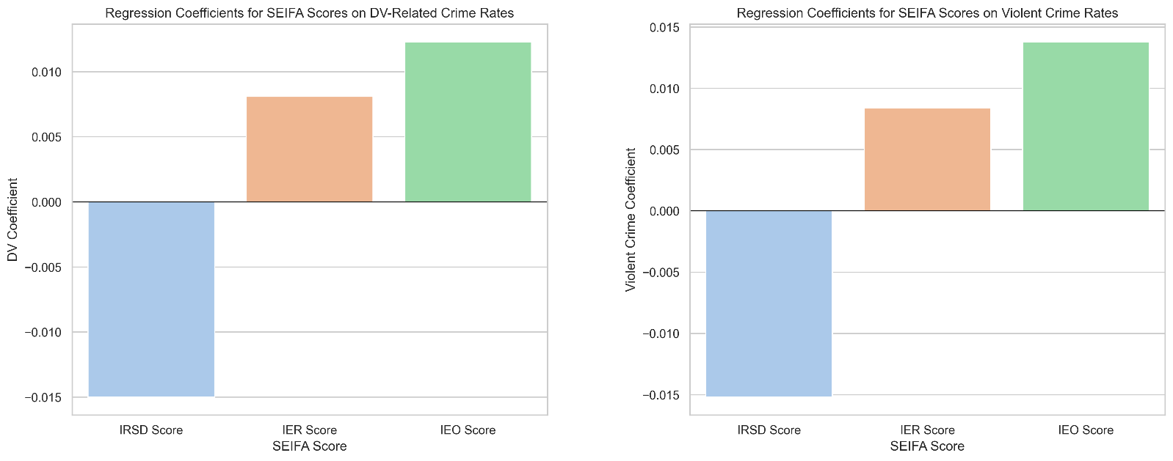

| ***SEIFA Score*** | ***DV Crime Coefficient*** | ***Violent Crime Coefficient*** |
| --- | --- | --- |
| *IRSD Score* | *-0.0150* | *-0.0152* |
| *IER Score* | *0.0081* | *0.0084* |
| *IEO Score* | *0.0123* | *0.0138* |

*All coefficients are statistically significant (p < 0.001).*

## 5. Visual Diagnostics

*The scatter plots below illustrate the model fit for actual vs. predicted crime rates:*

## 6. Interpretation of Key Findings

***6.1 IRSD Score (Disadvantage)***

* *A* ***negative relationship*** *was found: areas with higher disadvantage (lower IRSD scores) tend to have higher crime rates.*
* *This aligns with expectations, as disadvantaged areas may have weaker social cohesion or fewer resources for crime prevention.*

***6.2 IER & IEO Scores (Education, Employment, Economic Opportunity)***

* *A* ***positive relationship*** *emerged: surprisingly, areas with better education, employment, and opportunity had* ***slightly higher*** *crime rates.*
* *This may be due to:*
  + *Higher population density in economically active areas*
  + *Better reporting and policing infrastructure*
  + *Socio-economic inequality or micro pockets of disadvantage in otherwise advantaged areas*

## 7. Model Validity Checks

* ***Durbin-Watson statistic****: ~2.09 — indicates no significant autocorrelation*
* ***Omnibus & Jarque-Bera tests****: suggest residuals are approximately normally distributed*

*These diagnostics confirm that the assumptions of linear regression are sufficiently met.*

## 8. Conclusion

*This analysis reveals a complex but statistically significant relationship between socio-economic conditions and violent crime. While disadvantage (IRSD) is linked with higher crime, higher levels of opportunity and employment (IER, IEO) also correlate with crime, potentially reflecting structural and reporting dynamics rather than actual risk.*

*The model fit and statistical significance support the use of SEIFA scores as predictive tools for understanding community-level crime trends. These insights can help guide targeted interventions, community support initiatives, and policing strategies.*

***Data Sources***

* ***SEIFA Indexes (2021)*** *Australian Bureau of Statistics*[*https://www.abs.gov.au/statistics/people/people-and-communities/socio-economic-indexes-areas-seifa-australia/latest-release#data-downloads*](https://www.abs.gov.au/statistics/people/people-and-communities/socio-economic-indexes-areas-seifa-australia/latest-release#data-downloads)
* ***Crime Data by Police Division (2018–Latest)*** *Queensland Government Open Data Portal*[*https://www.data.qld.gov.au/dataset/offence-numbers-police-divisions-monthly-from-july-2001*](https://www.data.qld.gov.au/dataset/offence-numbers-police-divisions-monthly-from-july-2001)
* ***Code Repository*** *GitHub – Crime & SEIFA Analysis  
  (insert your GitHub repo URL here once uploaded)*